11.66: a) Taking torques about the right end of the stick, the friction force is half the weight of the stick,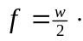 Taking torques about the point where the cord is attached to the wall (the tension in the cord and the friction force exert no torque about this point),and noting that the moment arm of the normal force is

b) Taking torques as in part (a), and denoting the length of the meter stick as
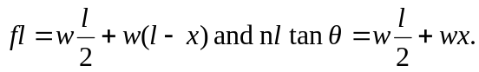
In terms of the coefficient of friction 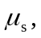
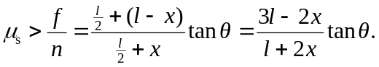
Solving for x,
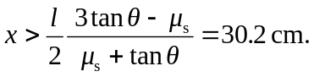
c) In the above expression, setting 